Development ... Using Laser Diagnostics
XXX XXX¹* , XXX XXX² and XXX XXX³
Tokushima University, Tokushima 770-8501, Japan
* E-mail: yyy@tokushima-u.ac.jp
² National Taiwan University of Science and Technology, Taipei City 10607, Taiwan
³ Xi’an Jiaotong University, Xi'an, 710049, China

1. Introduction
Author(s) will be requested to submit 1 to 3-page summary (pdf file) written in English. Use A4 size format and type your text in 10.5-point Times (New) Roman, single-spaced.
2. Experimental setup
Figures and Tables may be included in the abstract^{[1]}.
3. Results and discussion
................................................................................................................................................................................................................................................................................................
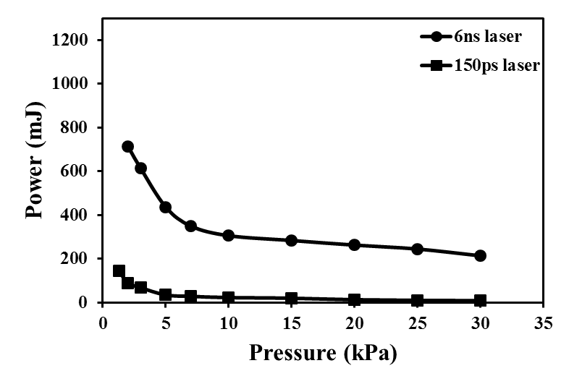
Fig.1 Air plasma generation threshold

4. Conclusion
1) ............
2) ............
References
[1] M. Noda, Y. Deguchi, S. Iwasaki, N. Yoshikawa, “Detection of Carbon Content in a High Temperature and High Pressure Environment Using Laser-Induced Breakdown Spectroscopy”. Spectrochim. Acta, Part B. 2002. 57: 701-709.
[2] ..........

